**Statistics**

**Nicholas Randles – B00058026**



**Contents**

Exercise 1………………………………………………………………………………………………………...1

* Mode………………………………………………………………………………………………….…1
* Median…………….………………………………………………………………………………….…2
* Arithmetic Mean………………………………………………….………………………………….…3
* How these measures are helpful……………………….………………………………………….…4

Exercise 2………………………………………………………………………………………………………...4

* Range………..……………………………………………………………………………………….…4
* Quartiles……………..……………………………………………………………………………….…5
* Variance………..…………………………………………………………………………………….…6
* Standard Deviation………………………………………………………………………………….…7
* Z-Score……………………………………………………………………………………………….…8
* How these measures are helpful……………….…………………………………………………..12

Exercise 3………………………………………………………………………………………………………12

* Skewness……………………………………………………………………………………………..12
* Kurtosis………………………………………………………………………………………………..13
* How these measures are helpful…………………………………..…………………………….…14

Exercise 4……………………………………………………………………………………………………....14

* Histograms……………………………………..…………………………………………………..…14
* Boxplots…………………………...………………………………………………………………..…17
* Scatter plot………………………………………………………………………………………….…19

**Exercise 1**

**Mode**

**Sepal.Length**

**R code:**

* my_mode <- table(iris$Sepal.Length)
* my_mode
* my_mode[which(my_mode ==max(my_mode))]

**Results:**

The value 5 occurred the most making it the mode. It occurred 10 times.

Mode = 5

**Sepal.Width**

**R code:**

* my_mode <- table(iris$Sepal.Width)
* my_mode
* my_mode[which(my_mode ==max(my_mode))]

**Results:**

The value 3 occurred the most making it the mode. It occurred 26 times.

Mode = 3

**Petal.Length**

**R code:**

* my_mode <- table(iris$Petal.Length)
* my_mode
* my_mode[which(my_mode ==max(my_mode))]

**Results:**

The mode here is {1.4, 1.5} as both 1.4 and 1.5 occur 13 times.

Mode = 1.4, 1.5

**Petal.Width**

**R code:**

* my_mode <- table(iris$Petal.Width)
* my_mode
* my_mode[which(my_mode ==max(my_mode))]

**Results:**

The value 0.2 occurred the most making it the mode. It occurred 29 times.

Mode = 0.2

**Median**

**Sepal.Length**

**R code:**

* median(iris$Sepal.Length)

**Results:**

Since there is an even amount of numbers the median has been created by adding the two middle numbers and dividing them by 2. The median for the variable Sepal.Length in the iris dataset is 5.8.

Median = 5.8

**Sepal.Width**

**R code:**

* median(iris$Sepal.Width)

**Results:**

The median for the variable Sepal.Width in the iris dataset is 3.

Median = 3

**Petal.Length**

**R code:**

* median(iris$Petal.Length)

**Results:**

The median for the variable Petal.Length in the iris dataset is 4.35.

Median = 4.35

**Petal.Width**

**R code:**

* median(iris$Petal.Width)

**Results:**

The median for the variable Petal.Width in the iris dataset is 1.3.

Median = 1.3

**Arithmetic Mean**

**Sepal.Length**

**R code:**

* mean(iris$Sepal.Length)

**Results:**

The mean for the variable Sepal.Length in the iris dataset is 5.84.

Arithmetic Mean = 5.84

**Sepal.Width**

**R code:**

* mean(iris$Sepal.Width)

**Results:**

The mean for the variable Sepal.Width in the iris dataset is 3.06.

Arithmetic Mean = 3.06

**Petal.Length**

**R code:**

* mean(iris$Petal.Length)

**Results:**

The mean for the variable Petal.Length in the iris dataset is 3.76.

Arithmetic Mean = 3.76

**Petal.Width**

**R code:**

* mean(iris$Petal.Width)

**Results:**

The mean for the variable Petal.Width in the iris dataset is 1.2.

Arithmetic Mean = 1.2

**How these measures are helpful**

All three of these measurements help us get a better understanding of the dataset.

* The arithmetic mean helps us find the average of the dataset. An advantage of the arithmetic mean is that all of the data is used. A disadvantage is that very large and small numbers can distort the answer.
* The mode helps us find the number that occurs the most in the dataset. An advantage of the mode is that it does not get affected by large and small values like the mean. A disadvantage is that it is not based on all of the values.
* The medium helps us find the middle value when the numbers are put in order from lowest to highest.

**Exercise 2**

**Range**

**Sepal.Length**

**R code:**

* min(iris$Sepal.Length)
* max(iris$Sepal.Length)
* range(iris$Sepal.Length)

**Results:**

The minimum value is 4.3 and the maximum value is 7.9. This makes the range 3.6.

Range: 7.6 – 4.3 = 3.6

**Sepal.Width**

**R code:**

* min(iris$Sepal.Width)
* max(iris$Sepal.Width)
* range(iris$Sepal.Width)

**Results:**

The minimum value is 2 and the maximum value is 4.4. This makes the range 2.4.

Range: 4.4 – 2 = 2.4

**Petal.Length**

**R code:**

* min(iris$Petal.Length)
* max(iris$Petal.Length)
* range(iris$Petal.Length)

**Results:**

The minimum value is 1 and the maximum value is 6.9. This makes the range 5.9.

Range: 6.9 – 1 = 5.9

**Petal.Width**

**R code:**

* min(iris$Petal.Width)
* max(iris$Petal.Width)
* range(iris$Petal.Width)

**Results:**

The minimum value is 0.1 and the maximum value is 2.5. This makes the range 2.4.

Range: 2.5 – 0.1 = 2.4

**Quartiles**

**Sepal.Length**

**R code:**

* quantile(iris$Sepal.Length)

**Results:**

The value at 0% is 4.3, the value at 25% is 5.1, the value at 50% is 5.8, the value at 75% is 6.4, and the value at 100% is 7.9. The first quartile is always at 25% making it 5.1. The second quartile is at 50% making it 5.8. And the third quartile is at 75% making it 6.4.

Q1 = 5.1

Q2 = 5.8

Q3 = 6.4

**Sepal.Width**

**R code:**

* quantile(iris$Sepal.Width)

**Results:**

The value at 0% is 2, the value at 25% is 2.8, the value at 50% is 3, the value at 75% is 3.3, and the value at 100% is 4.4. The first quartile is always at 25% making it 2.8. The second quartile is at 50% making it 3. And the third quartile is at 75% making it 3.3.

Q1 = 2.8

Q2 = 3

Q3 = 3.3

**Petal.Length**

**R code:**

* quantile(iris$Petal.Length)

**Results:**

The value at 0% is 1, the value at 25% is 1.6, the value at 50% is 4.35, the value at 75% is 5.1, and the value at 100% is 6.9. The first quartile is always at 25% making it 1.6. The second quartile is at 50% making it 4.35. And the third quartile is at 75% making it 5.1.

Q1 = 1.6

Q2 = 4.35

Q3 = 5.1

**Petal.Width**

**R code:**

* quantile(iris$Petal.Width)

**Results:**

The value at 0% is 0.1, the value at 25% is 0.3, the value at 50% is 1.3, the value at 75% is 1.8, and the value at 100% is 2.5. The first quartile is always at 25% making it 0.3. The second quartile is at 50% making it 1.3. And the third quartile is at 75% making it 1.8.

Q1 = 0.3

Q2 = 1.3

Q3 = 1.8

**Variance**

**Sepal.Length**

**R code:**

* var(iris$Sepal.Length)

**Results:**

The variance of the variable Sepal.Length is 0.69.

Variance = 0.69

**Sepal.Width**

**R code:**

* var(iris$Sepal.Width)

**Results:**

The variance of the variable Sepal.Width is 0.19.

Variance = 0.19

**Petal.Length**

**R code:**

* var(iris$Petal.Length)

**Results:**

The variance of the variable Petal.Length is 3.12.

Variance = 3.12

**Petal.Width**

**R code:**

* var(iris$Petal.Width)

**Results:**

The variance of the variable Petal.Width is 0.58.

Variance = 0.58

**Standard Deviation**

**Sepal.Length**

**R code:**

* sd(iris$Sepal.Length)

**Results:**

The standard deviation of the variable Sepal.Length is 0.83.

Standard Deviation = 0.83

**Sepal.Width**

**R code:**

* sd(iris$Sepal.Width)

**Results:**

The standard deviation of the variable Sepal.Width is 0.44.

Standard Deviation = 0.44

**Petal.Length**

**R code:**

* sd(iris$Petal.Length)

**Results:**

The standard deviation of the variable Petal.Length is 1.77.

Standard Deviation = 1.77

**Petal.Width**

**R code:**

* sd(iris$Petal.Width)

**Results:**

The standard deviation of the variable Petal.Width is 0.76.

Standard Deviation = 0.76

**Z-Score**

**Sepal.Length**

**R code:**

* x<-((iris$Sepal.Length)-mean(iris$Sepal.Length))/sd(iris$Sepal.Length)
* x

**Results:**

[1] -0.89767388 -1.13920048 -1.38072709 -1.50149039 -1.01843718 -0.53538397 -1.50149039

[8] -1.01843718 -1.74301699 -1.13920048 -0.53538397 -1.25996379 -1.25996379 -1.86378030

[15] -0.05233076 -0.17309407 -0.53538397 -0.89767388 -0.17309407 -0.89767388 -0.53538397

[22] -0.89767388 -1.50149039 -0.89767388 -1.25996379 -1.01843718 -1.01843718 -0.77691058

[29] -0.77691058 -1.38072709 -1.25996379 -0.53538397 -0.77691058 -0.41462067 -1.13920048

[36] -1.01843718 -0.41462067 -1.13920048 -1.74301699 -0.89767388 -1.01843718 -1.62225369

[43] -1.74301699 -1.01843718 -0.89767388 -1.25996379 -0.89767388 -1.50149039 -0.65614727

[50] -1.01843718 1.39682886 0.67224905 1.27606556 -0.41462067 0.79301235 -0.17309407

[57] 0.55148575 -1.13920048 0.91377565 -0.77691058 -1.01843718 0.06843254 0.18919584

[64] 0.30995914 -0.29385737 1.03453895 -0.29385737 -0.05233076 0.43072244 -0.29385737

[71] 0.06843254 0.30995914 0.55148575 0.30995914 0.67224905 0.91377565 1.15530226

[78] 1.03453895 0.18919584 -0.17309407 -0.41462067 -0.41462067 -0.05233076 0.18919584

[85] -0.53538397 0.18919584 1.03453895 0.55148575 -0.29385737 -0.41462067 -0.41462067

[92] 0.30995914 -0.05233076 -1.01843718 -0.29385737 -0.17309407 -0.17309407 0.43072244

[99] -0.89767388 -0.17309407 0.55148575 -0.05233076 1.51759216 0.55148575 0.79301235

[106] 2.12140867 -1.13920048 1.75911877 1.03453895 1.63835547 0.79301235 0.67224905

[113] 1.15530226 -0.17309407 -0.05233076 0.67224905 0.79301235 2.24217198 2.24217198

[120] 0.18919584 1.27606556 -0.29385737 2.24217198 0.55148575 1.03453895 1.63835547

[127] 0.43072244 0.30995914 0.67224905 1.63835547 1.87988207 2.48369858 0.67224905

[134] 0.55148575 0.30995914 2.24217198 0.55148575 0.67224905 0.18919584 1.27606556

[141] 1.03453895 1.27606556 -0.05233076 1.15530226 1.03453895 1.03453895 0.55148575

[148] 0.79301235 0.43072244 0.06843254

**Sepal.Width**

**R code:**

* x<-((iris$Sepal.Width)-mean(iris$Sepal.Width))/sd(iris$Sepal.Width)
* x

**Results:**

[1] 1.01560199 -0.13153881 0.32731751 0.09788935 1.24503015 1.93331463 0.78617383

[8] 0.78617383 -0.36096697 0.09788935 1.47445831 0.78617383 -0.13153881 -0.13153881

[15] 2.16274279 3.08045544 1.93331463 1.01560199 1.70388647 1.70388647 0.78617383

[22] 1.47445831 1.24503015 0.55674567 0.78617383 -0.13153881 0.78617383 1.01560199

[29] 0.78617383 0.32731751 0.09788935 0.78617383 2.39217095 2.62159911 0.09788935

[36] 0.32731751 1.01560199 1.24503015 -0.13153881 0.78617383 1.01560199 -1.73753594

[43] 0.32731751 1.01560199 1.70388647 -0.13153881 1.70388647 0.32731751 1.47445831

[50] 0.55674567 0.32731751 0.32731751 0.09788935 -1.73753594 -0.59039513 -0.59039513

[57] 0.55674567 -1.50810778 -0.36096697 -0.81982329 -2.42582042 -0.13153881 -1.96696410

[64] -0.36096697 -0.36096697 0.09788935 -0.13153881 -0.81982329 -1.96696410 -1.27867961

[71] 0.32731751 -0.59039513 -1.27867961 -0.59039513 -0.36096697 -0.13153881 -0.59039513

[78] -0.13153881 -0.36096697 -1.04925145 -1.50810778 -1.50810778 -0.81982329 -0.81982329

[85] -0.13153881 0.78617383 0.09788935 -1.73753594 -0.13153881 -1.27867961 -1.04925145

[92] -0.13153881 -1.04925145 -1.73753594 -0.81982329 -0.13153881 -0.36096697 -0.36096697

[99] -1.27867961 -0.59039513 0.55674567 -0.81982329 -0.13153881 -0.36096697 -0.13153881

[106] -0.13153881 -1.27867961 -0.36096697 -1.27867961 1.24503015 0.32731751 -0.81982329

[113] -0.13153881 -1.27867961 -0.59039513 0.32731751 -0.13153881 1.70388647 -1.04925145

[120] -1.96696410 0.32731751 -0.59039513 -0.59039513 -0.81982329 0.55674567 0.32731751

[127] -0.59039513 -0.13153881 -0.59039513 -0.13153881 -0.59039513 1.70388647 -0.59039513

[134] -0.59039513 -1.04925145 -0.13153881 0.78617383 0.09788935 -0.13153881 0.09788935

[141] 0.09788935 0.09788935 -0.81982329 0.32731751 0.55674567 -0.13153881 -1.27867961

[148] -0.13153881 0.78617383 -0.13153881

**Petal.Length**

**R code:**

* x<-((iris$Petal.Length)-mean(iris$Petal.Length))/sd(iris$Petal.Length)
* x

**Results:**

[1] -1.33575163 -1.33575163 -1.39239929 -1.27910398 -1.33575163 -1.16580868 -1.33575163

[8] -1.27910398 -1.33575163 -1.27910398 -1.27910398 -1.22245633 -1.33575163 -1.50569459

[15] -1.44904694 -1.27910398 -1.39239929 -1.33575163 -1.16580868 -1.27910398 -1.16580868

[22] -1.27910398 -1.56234224 -1.16580868 -1.05251337 -1.22245633 -1.22245633 -1.27910398

[29] -1.33575163 -1.22245633 -1.22245633 -1.27910398 -1.27910398 -1.33575163 -1.27910398

[36] -1.44904694 -1.39239929 -1.33575163 -1.39239929 -1.27910398 -1.39239929 -1.39239929

[43] -1.39239929 -1.22245633 -1.05251337 -1.33575163 -1.22245633 -1.33575163 -1.27910398

[50] -1.33575163 0.53362088 0.42032558 0.64691619 0.13708732 0.47697323 0.42032558

[57] 0.53362088 -0.25944625 0.47697323 0.08043967 -0.14615094 0.25038262 0.13708732

[64] 0.53362088 -0.08950329 0.36367793 0.42032558 0.19373497 0.42032558 0.08043967

[71] 0.59026853 0.13708732 0.64691619 0.53362088 0.30703027 0.36367793 0.59026853

[78] 0.70356384 0.42032558 -0.14615094 0.02379201 -0.03285564 0.08043967 0.76021149

[85] 0.42032558 0.42032558 0.53362088 0.36367793 0.19373497 0.13708732 0.36367793

[92] 0.47697323 0.13708732 -0.25944625 0.25038262 0.25038262 0.25038262 0.30703027

[99] -0.42938920 0.19373497 1.27004036 0.76021149 1.21339271 1.04344975 1.15674505

[106] 1.60992627 0.42032558 1.43998331 1.15674505 1.32668801 0.76021149 0.87350679

[113] 0.98680210 0.70356384 0.76021149 0.87350679 0.98680210 1.66657392 1.77986923

[120] 0.70356384 1.10009740 0.64691619 1.66657392 0.64691619 1.10009740 1.27004036

[127] 0.59026853 0.64691619 1.04344975 1.15674505 1.32668801 1.49663097 1.04344975

[134] 0.76021149 1.04344975 1.32668801 1.04344975 0.98680210 0.59026853 0.93015445

[141] 1.04344975 0.76021149 0.76021149 1.21339271 1.10009740 0.81685914 0.70356384

[148] 0.81685914 0.93015445 0.76021149

**Petal.Width**

**R code:**

* x<-((iris$Petal.Width)-mean(iris$Petal.Width))/sd(iris$Petal.Width)
* x

**Results:**

[1] -1.3110521482 -1.3110521482 -1.3110521482 -1.3110521482 -1.3110521482 -1.0486667950

[7] -1.1798594716 -1.3110521482 -1.3110521482 -1.4422448248 -1.3110521482 -1.3110521482

[13] -1.4422448248 -1.4422448248 -1.3110521482 -1.0486667950 -1.0486667950 -1.1798594716

[19] -1.1798594716 -1.1798594716 -1.3110521482 -1.0486667950 -1.3110521482 -0.9174741184

[25] -1.3110521482 -1.3110521482 -1.0486667950 -1.3110521482 -1.3110521482 -1.3110521482

[31] -1.3110521482 -1.0486667950 -1.4422448248 -1.3110521482 -1.3110521482 -1.3110521482

[37] -1.3110521482 -1.4422448248 -1.3110521482 -1.3110521482 -1.1798594716 -1.1798594716

[43] -1.3110521482 -0.7862814418 -1.0486667950 -1.1798594716 -1.3110521482 -1.3110521482

[49] -1.3110521482 -1.3110521482 0.2632599711 0.3944526477 0.3944526477 0.1320672944

[55] 0.3944526477 0.1320672944 0.5256453243 -0.2615107354 0.1320672944 0.2632599711

[61] -0.2615107354 0.3944526477 -0.2615107354 0.2632599711 0.1320672944 0.2632599711

[67] 0.3944526477 -0.2615107354 0.3944526477 -0.1303180588 0.7880306775 0.1320672944

[73] 0.3944526477 0.0008746178 0.1320672944 0.2632599711 0.2632599711 0.6568380009

[79] 0.3944526477 -0.2615107354 -0.1303180588 -0.2615107354 0.0008746178 0.5256453243

[85] 0.3944526477 0.5256453243 0.3944526477 0.1320672944 0.1320672944 0.1320672944

[91] 0.0008746178 0.2632599711 0.0008746178 -0.2615107354 0.1320672944 0.0008746178

[97] 0.1320672944 0.1320672944 -0.1303180588 0.1320672944 1.7063794137 0.9192233541

[103] 1.1816087073 0.7880306775 1.3128013839 1.1816087073 0.6568380009 0.7880306775

[109] 0.7880306775 1.7063794137 1.0504160307 0.9192233541 1.1816087073 1.0504160307

[115] 1.5751867371 1.4439940605 0.7880306775 1.3128013839 1.4439940605 0.3944526477

[121] 1.4439940605 1.0504160307 1.0504160307 0.7880306775 1.1816087073 0.7880306775

[127] 0.7880306775 0.7880306775 1.1816087073 0.5256453243 0.9192233541 1.0504160307

[133] 1.3128013839 0.3944526477 0.2632599711 1.4439940605 1.5751867371 0.7880306775

[139] 0.7880306775 1.1816087073 1.5751867371 1.4439940605 0.9192233541 1.4439940605

**How these measures are helpful**

All of these measurements help us get a better understanding of the dataset.

* The range shows us the extremes of the dataset. It helps us see the spread of the data. It shows us the difference between the minimum and maximum values in the dataset. It is strongly affected by outliers and doesn’t take clustering into account, so we need other measures to see the distribution better.
* The quartiles help us by splitting the data into for quarters. This helps us see the distribution at different points of the dataset.
* The variance helps us measure the spread of the data in relation to the mean. This helps us see how much data deviates from the average.
* The standard deviation give us the square root of the variance. It helps show us the deviation from the mean. We know how well the values are distributed around the mean based on how high the number is.
* The z-score helps us see how far a particular value is from the mean based on the number of standard deviations.

**Exercise 3**

**Skewness**

**Sepal.Length**

**R code:**

* skewness(iris$Sepal.Length)

**Results:**

The skewness of the Sepal.Length variable is 0.31.

Skewness = 0.31

**Sepal.Width**

**R code:**

* skewness(iris$Sepal.Width)

**Results:**

The skewness of the Sepal.Width variable is 0.32.

Skewness = 0.32

**Petal.Length**

**R code:**

* skewness(iris$Petal.Length)

**Results:**

The skewness of the Petal.Length variable is -0.27.

Skewness = -0.27

**Petal.Width**

**R code:**

* skewness(iris$Petal.Width)

**Results:**

The skewness of the Petal.Width variable is -0.10.

Skewness = -0.10

**Kurtosis**

**Sepal.Length**

**R code:**

* kurtosis(iris$Sepal.Length)

**Results:**

The Sepal.Length variable has a kurtosis score of 2.43.

Kurtosis = 2.43

**Sepal.Width**

**R code:**

* kurtosis(iris$Sepal.Width)

**Results:**

The Sepal.Width variable has a kurtosis score of 3.18.

Kurtosis = 3.18

**Petal.Length**

**R code:**

* kurtosis(iris$Petal.Length)

**Results:**

The Petal.Length variable has a kurtosis score of 1.60.

Kurtosis = 1.60

**Petal.Width**

**R code:**

* kurtosis(iris$Petal.Width)

**Results:**

The Petal.Width variable has a kurtosis score of 1.66.

Kurtosis = 1.66

**How these measures are helpful**

Both of these measurements help us get a better understanding of the dataset. They help us get a better understanding of the distribution of the data.

* Skewness helps us to measure the lack of symmetry in the distribution of a variable. If we get a skewness value of 0 we know the data is distributed symmetrically. If we get positive numbers this indicates asymmetry to the left and if we get a negative number this indicates asymmetry to the right.
* Kurtosis helps us to see where the peak of the distribution is in the dataset. If the kurtosis score is high we know the peak is more pronounced towards the mean. If it is a flat peak it will have a low kurtosis score.

**Exercise 4**

**Histograms**

Histograms are good for showing the distribution of large sets of data. I have created histograms for the 4 variables of the iris dataset to show their distribution. You can tell if the data is distributed symmetrically, or is positively or negatively skewed by analysing the histograms.

**Sepal.Length**

**R code:**

* hist(iris$Sepal.Length, main="Histogram of Sepal.Length", xlab="Sepal.Length")

**Results:**

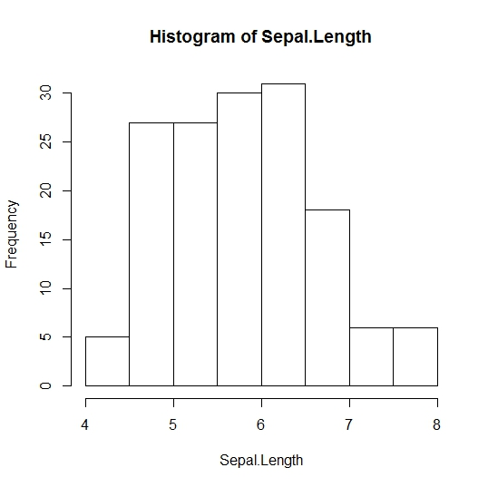

**Figure 1: Histogram of Sepal.Length**

**Sepal.Width**

**R code:**

* hist(iris$Sepal.Width, main="Histogram of Sepal.Width", xlab="Sepal.Width")

**Results:**

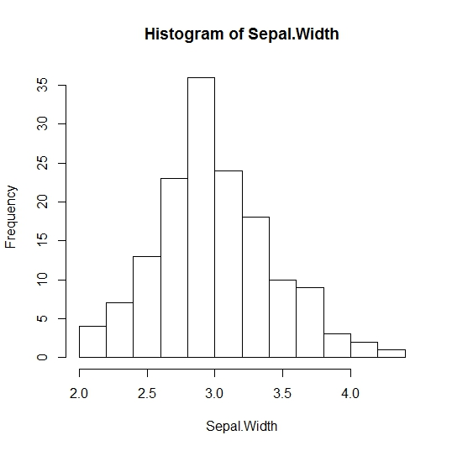

**Figure 2: Histogram of Sepal.Width**

**Petal.Length**

**R code:**

* hist(iris$Petal.Length, main="Histogram of Petal.Length", xlab="Petal.Length")

**Results:**

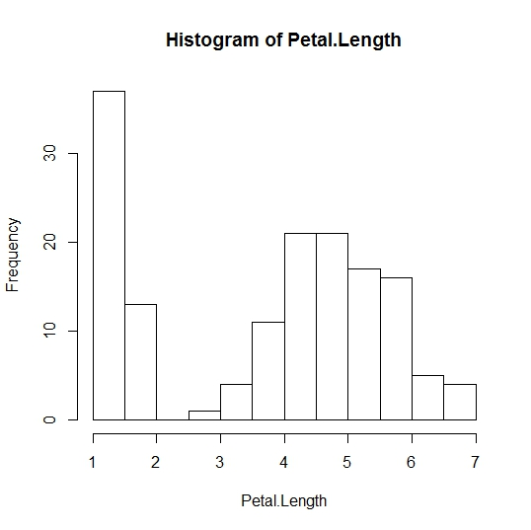

**Figure 3: Histogram of Petal.Length**

**Petal.Width**

**R code:**

* hist(iris$Petal.Width, main="Histogram of Petal.Width", xlab="Petal.Width")

**Results:**

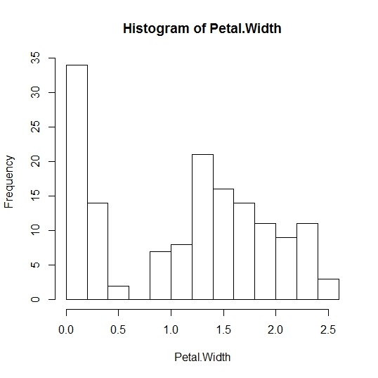

**Figure 4: Histogram of Petal.Width**

**Boxplots**

A boxplot is a graph that shows the minimum data value, lower quartile, median, upper quartile and maximum data value. It is a good visual aid to help examine the important values of a variable.

**Sepal.Length**

**R code:**

* boxplot(iris$Sepal.Length, main="Boxplot of Sepal.Length")

**Results:**

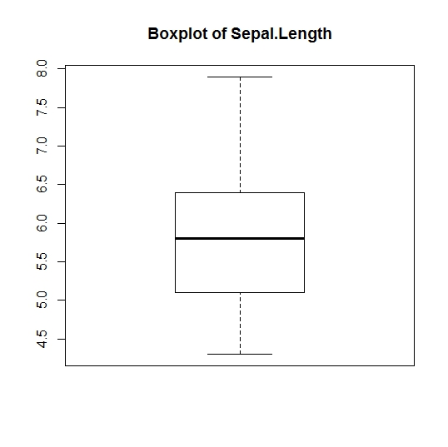

**Figure 5: Boxplot of Sepal.Length**

**Sepal.Width**

**R code:**

* boxplot(iris$Sepal.Width, main="Boxplot of Sepal.Width")

**Results:**

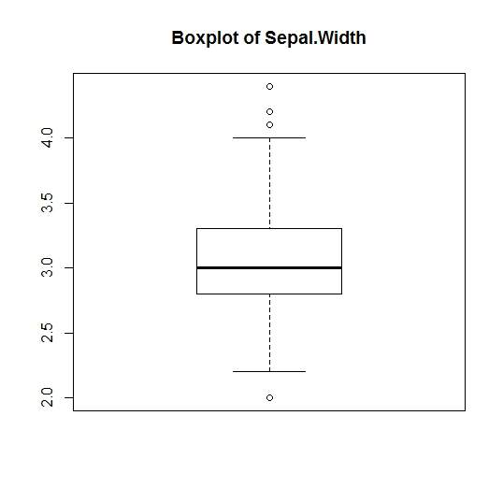

**Figure 6: Boxplot of Sepal.Width**

**Petal.Length**

**R code:**

* boxplot(iris$Petal.Length, main="Boxplot of Petal.Length")

**Results:**

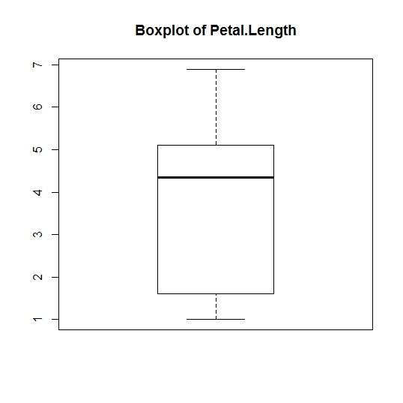

**Figure 7: Boxplot of Petal.Length**

**Petal.Width**

**R code:**

* boxplot(iris$Petal.Width, main="Boxplot of Petal.Width")

**Results:**

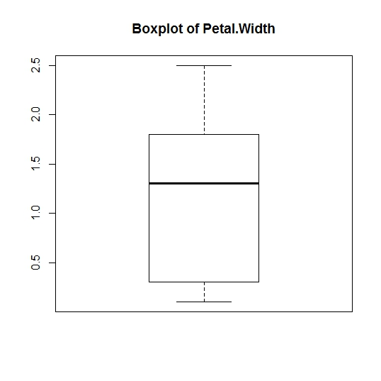

**Figure 8: Boxplot of Petal.Width**

**Scatter plots**

A scatter plot is a graph used to measure the relationship between two variables. One of the variables is plotted on the x-axis and the other is plotted on the y-axis. You can then see if there is correlation between them.

**Sepal.Length vs Sepal.Width**

**R code:**

* plot(iris$Sepal.Length ~ iris$Sepal.Width, main="Sepal.Length vs Sepal.Width", xlab="Sepal.Width", ylab="Sepal.Length")

**Results:**

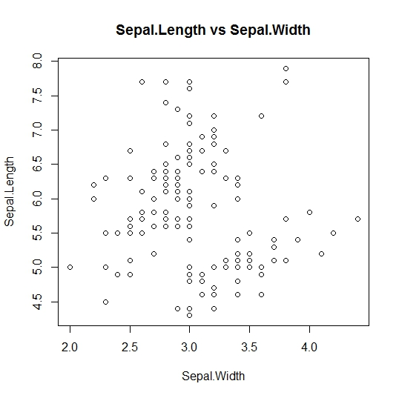

**Figure 9: Scatter plot of Sepal.Length vs Sepal.Width**

**Sepal.Length vs Petal.Length**

**R code:**

* plot(iris$Sepal.Length ~ iris$Petal.Length, main="Sepal.Length vs Petal.Length", xlab="Petal.Length", ylab="Sepal.Length")

**Results:**

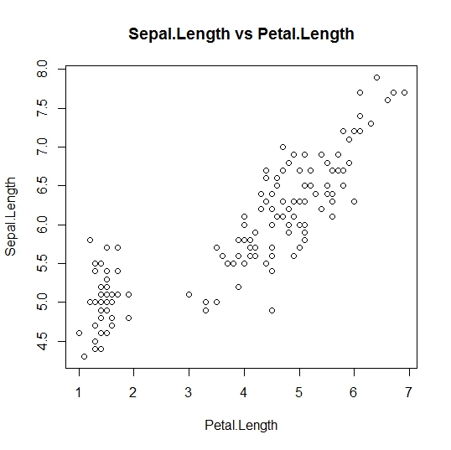

**Figure 10: Scatter plot of Sepal.Length vs Petal.Length**

**Sepal.Length vs Petal.Width**

**R code:**

* plot(iris$Sepal.Length ~ iris$Petal.Width, main="Sepal.Length vs Petal.Width", xlab="Petal.Width", ylab="Sepal.Length")

**Results:**

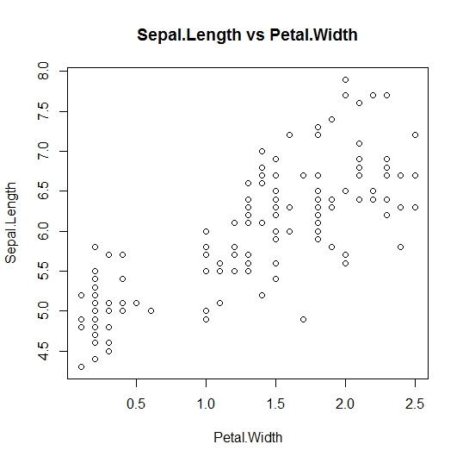

**Figure 11: Scatter plot of Sepal.Length vs Petal.Width**

**Sepal.Width vs Petal.Length**

**R code:**

* plot(iris$Sepal.Width ~ iris$Petal.Length, main="Sepal.Width vs Petal.Length", xlab="Petal.Length", ylab="Sepal.Width")

**Results:**

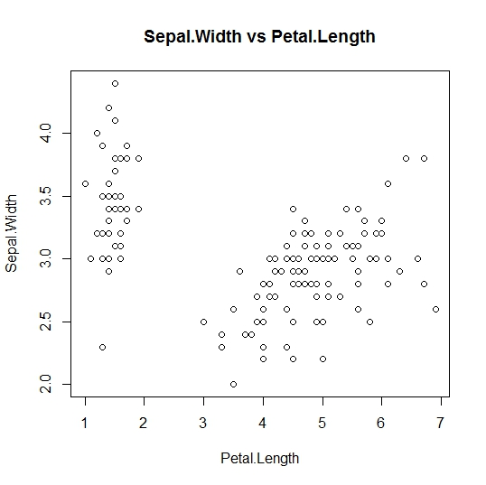

**Figure 12: Scatter plot of Sepal.Width vs Petal.Length**

**Sepal.Width vs Petal.Width**

**R code:**

* plot(iris$Sepal.Width ~ iris$Petal.Width, main="Sepal.Width vs Petal.Width", xlab="Petal.Width", ylab="Sepal.Width")

**Results:**

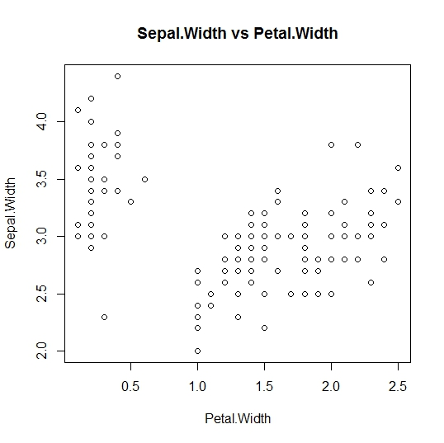

**Figure 13: Scatter plot of Sepal.Width vs Petal.Width**

**Petal.Length vs Petal.Width**

**R code:**

* plot(iris$Petal.Length ~ iris$Petal.Width, main="Petal.Length vs Petal.Width", xlab="Petal.Width", ylab="Petal.Length")

**Results:**

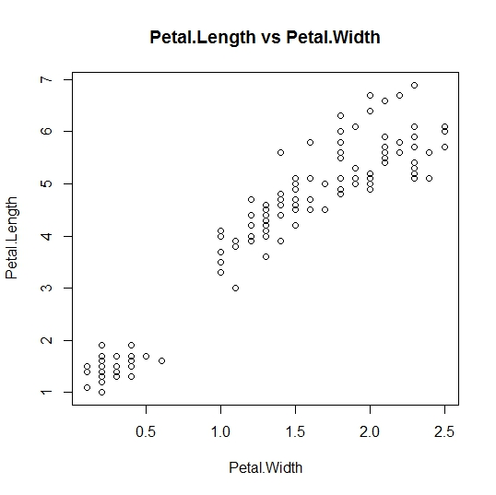

**Figure 14: Scatter plot of Petal.Length vs Petal.Width**